Europe Day 2012 with the children of Timisosra
400 children of elementary schools of Timisoara(Romania) have been protagonists of the “Europe Day 2012” in their city. The initiative has been promoted and organized by the European Journalists Association-The Communication Network (EJ) jointly with the West University Timisoara (UVT) and its “European Studies Center Alcide De Gasperi”. Present and former students of the Master on European Journalisms an Communication in Multiethnic Regions” of the UVT went to the schould to make a presentation about the European Union; afterwards the children made paintings and wrote texts about Europe on placards. EJ member and former student of the European Journalism Master Corina Sfia coordinated the several phases of the event.
In the morning of the 9th of May they gathered in Piaţa Unirii and bringing placards and European balloons crossed the city under protection of the local police delivering to the public flyers with European messages and reaching the UVT, where they were welcomes by the Rector prof. Marilen Pirtea accompanied by the EJ President and director of the De Gasperi Center Paolo Magagnotti. Afterwards they entered the Aula Magna forming the “European Parliament of the Children”. Professors and former students of the Master on Journalism acted as “European Commissioners” answered the endless questions of the children.
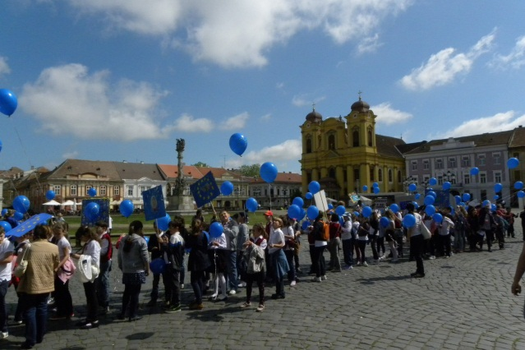
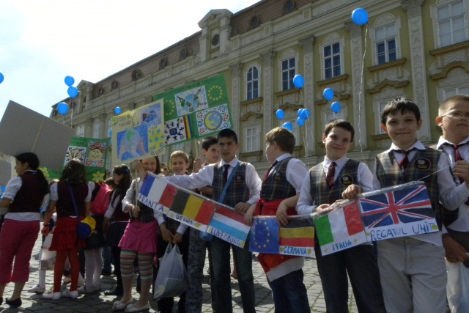
The debate was concluded with children’s messages to the EU Institutions to undertake all the measures to overcome asap the financial crises and to act for giving more hope to the young people for their future in a united Europe being guarantee for peace, solidarity and wellbeing.
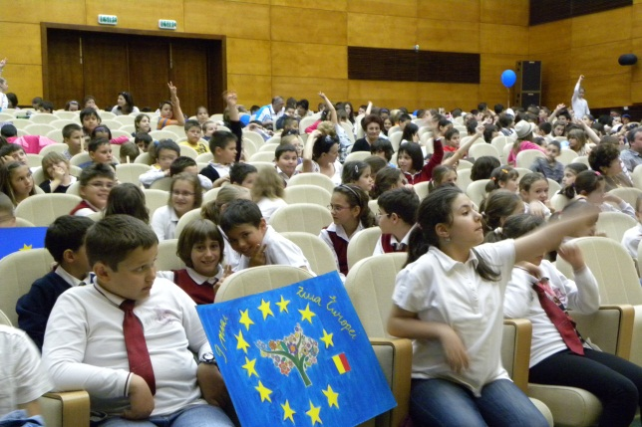
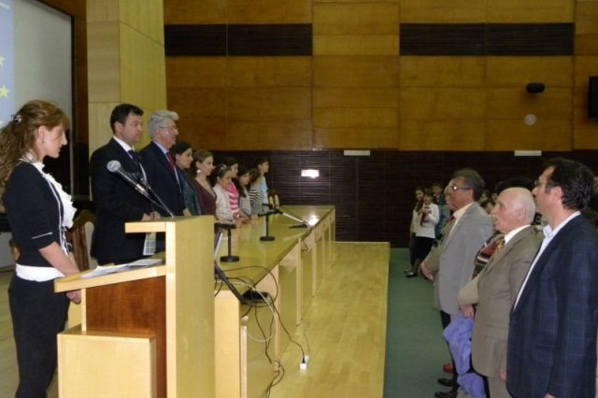
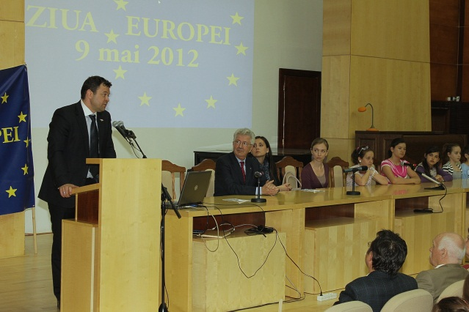
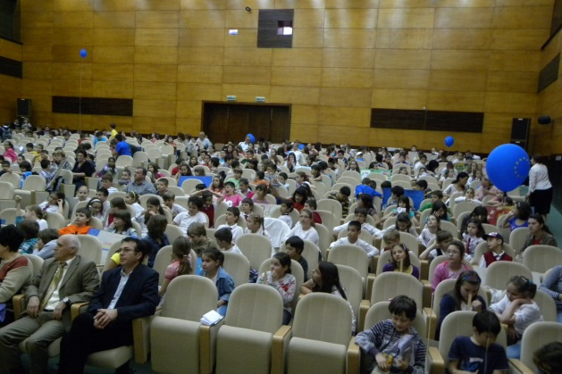
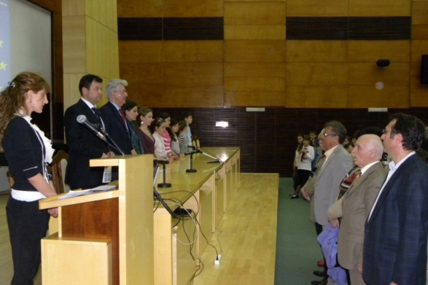

hhhh

